Nivin Pauly Post‘s - On A Friday

Cumulative Number's :

Total Post's : 17
Total Views : 71,80,205 (71.8L)
Total Likes: 4,43,752

1.Jacobinte Swargarajyam Reel ( Feb 11)

https://www.instagram.com/reel/DUn7x5aAdNp/?utm_source=ig_web_copy_link&igsh=MzRlODBiNWFlZA==

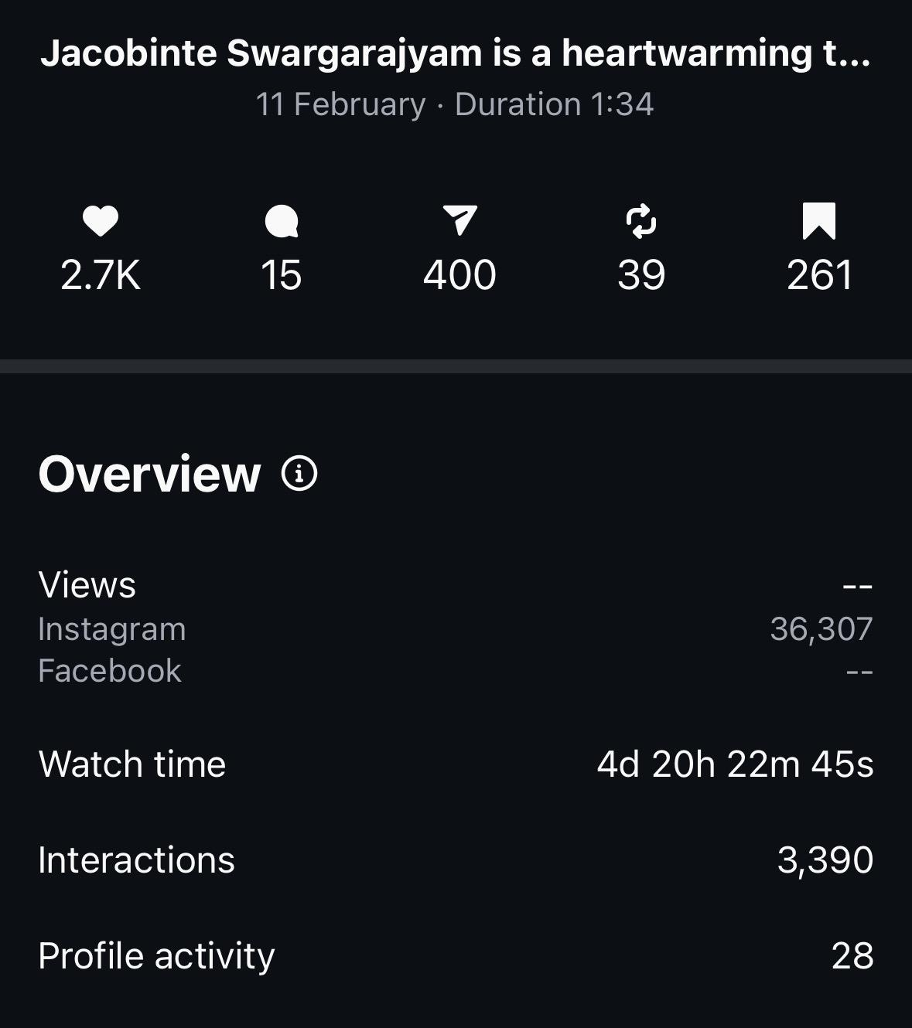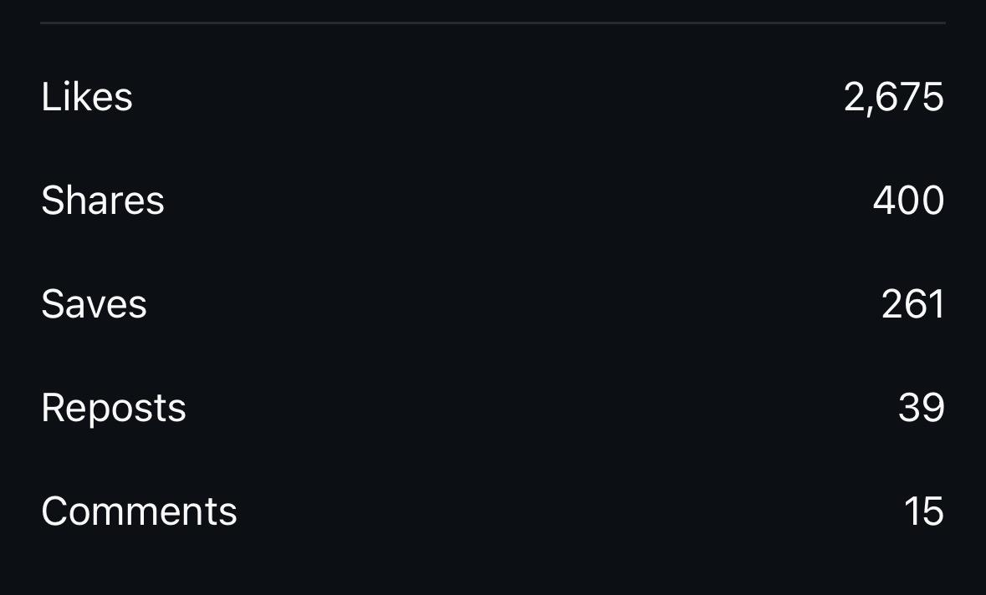

2.Sarvam Maya Reel (Feb 1)

https://www.instagram.com/reel/DUOTpCiAdqZ/?igsh=MXZlNWs3cGM4dW5zaQ==

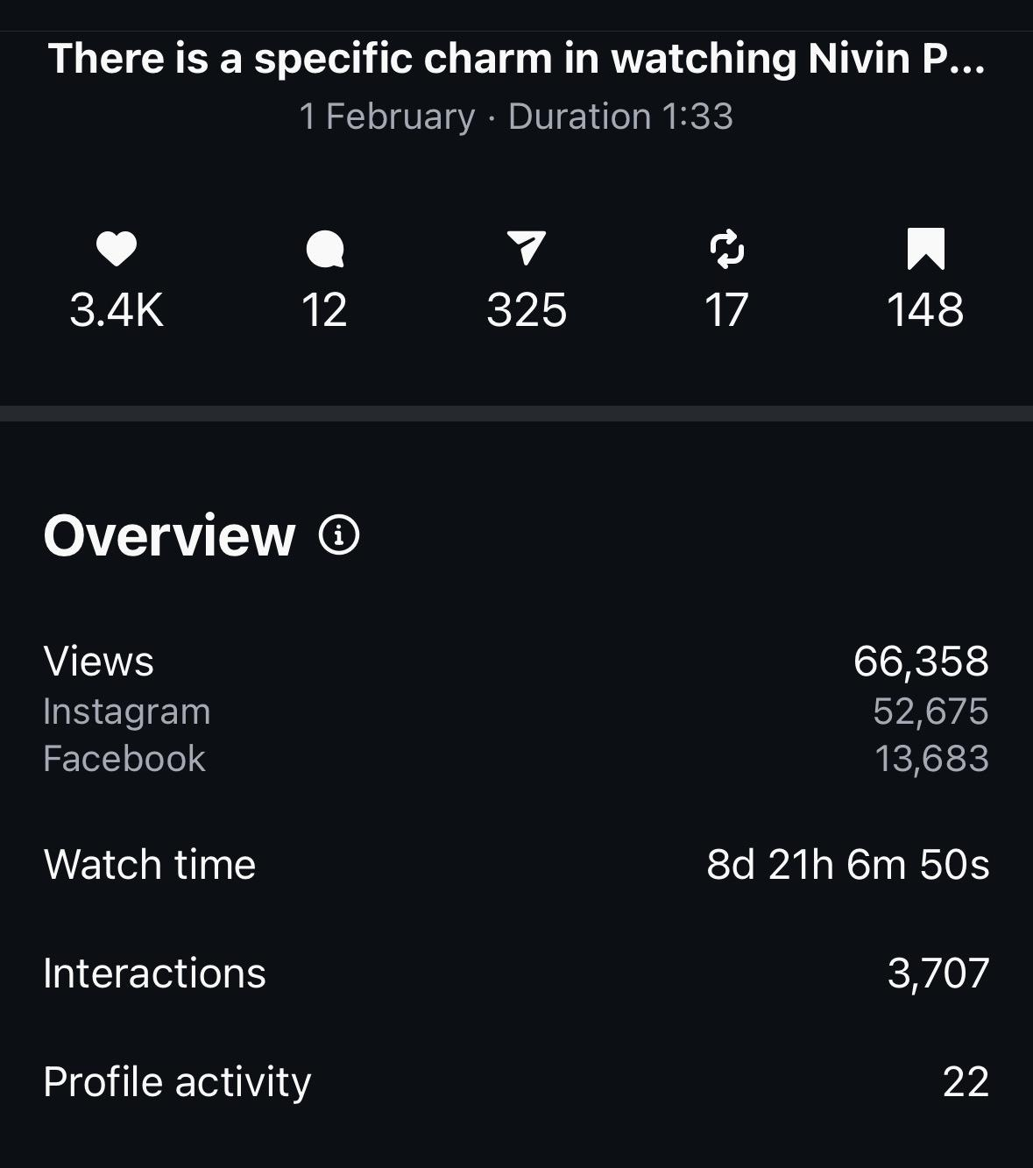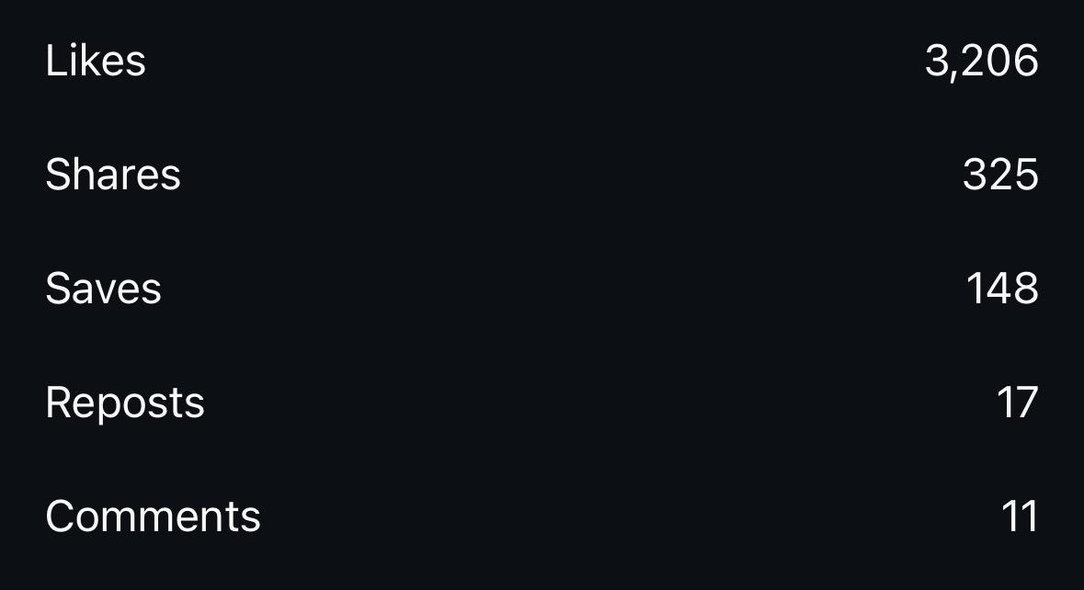

3. Njandukalude Naatil Oruidevala Reel (Jan 28)

https://www.instagram.com/reel/DUD4omggf_u/?igsh=YWFiYzJyOHFmbG9w

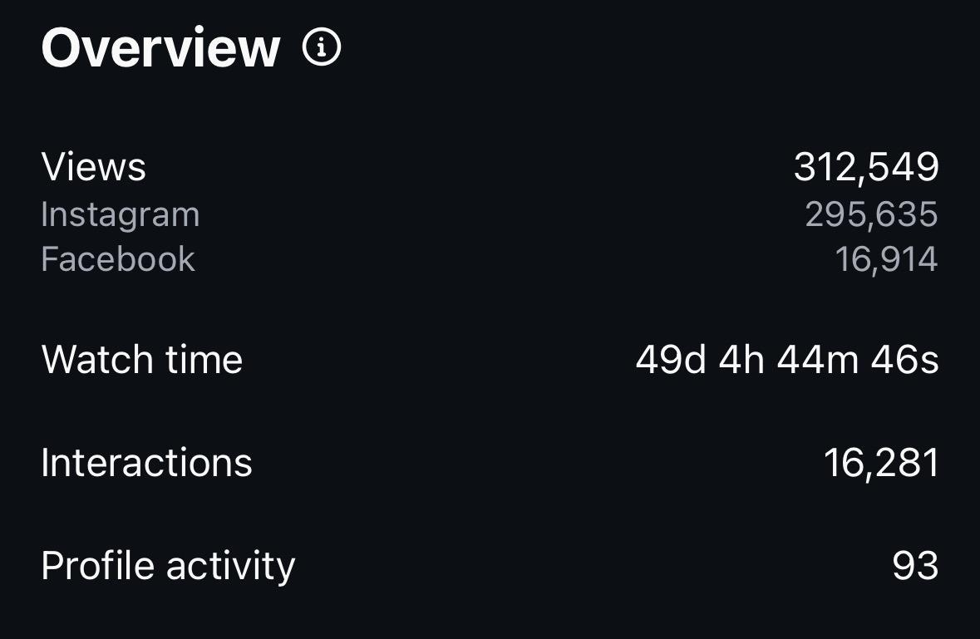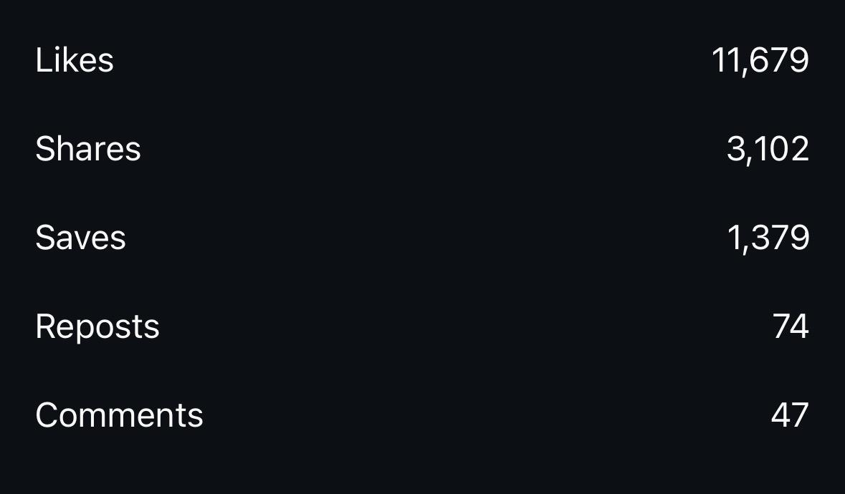

4. Action Hero Biju Reel (Jan 18)

https://www.instagram.com/reel/DTqCkTyAXen/?igsh=MWQ4ajk2bG9sazJhbA==

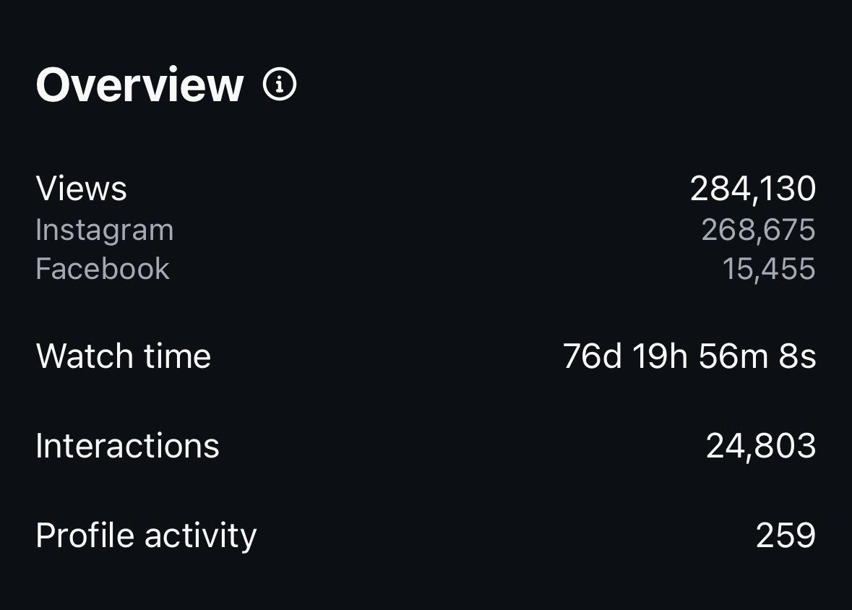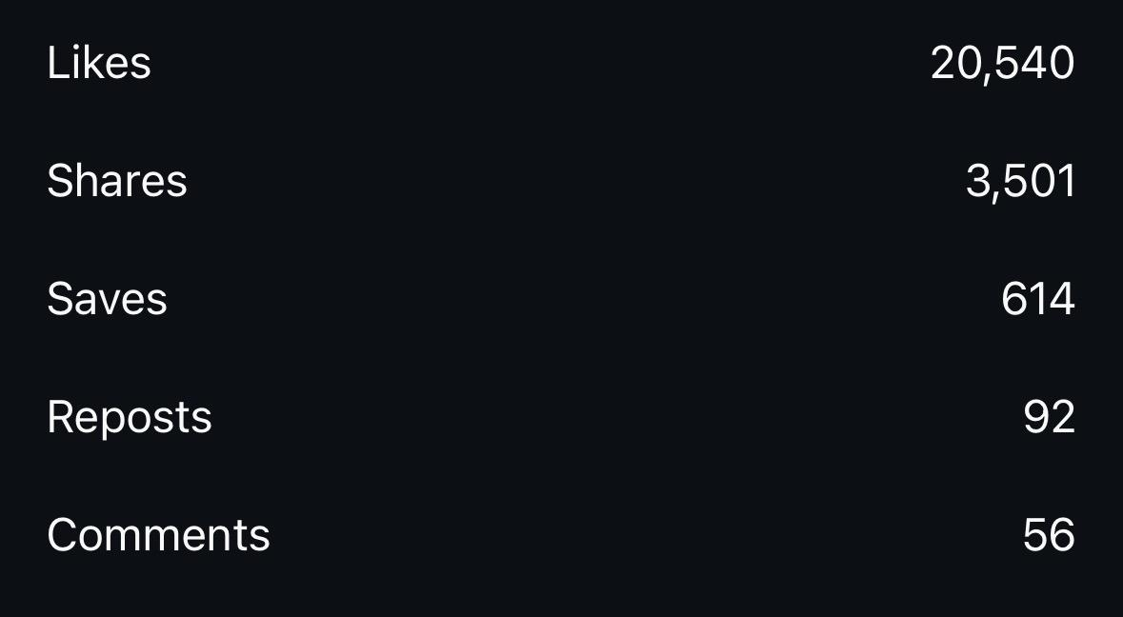

5. Nivin - Akhil Sathyan: Quick Bites Post (Jan 17)

https://www.instagram.com/p/DTmkYPSApzG/?igsh=dm5hdDRvYW01bmY5

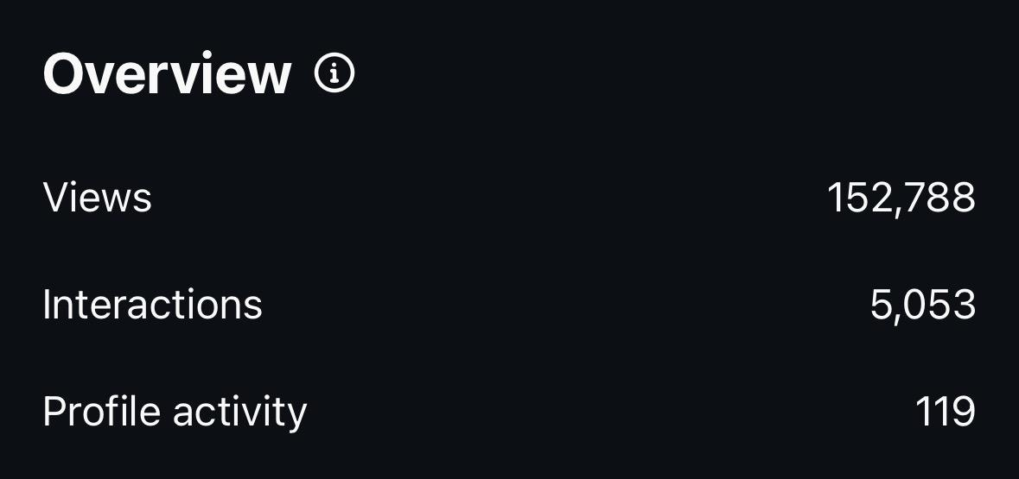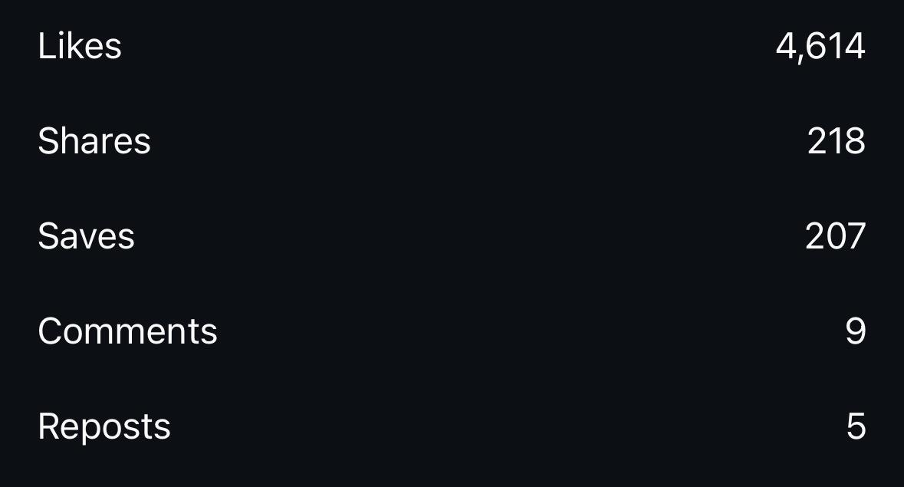

6. Baby Girl : Quick Bites Post ( Jan 10)

https://www.instagram.com/p/DTVqgG9gTIl/?igsh=a29wOGlsbGhqMXNr

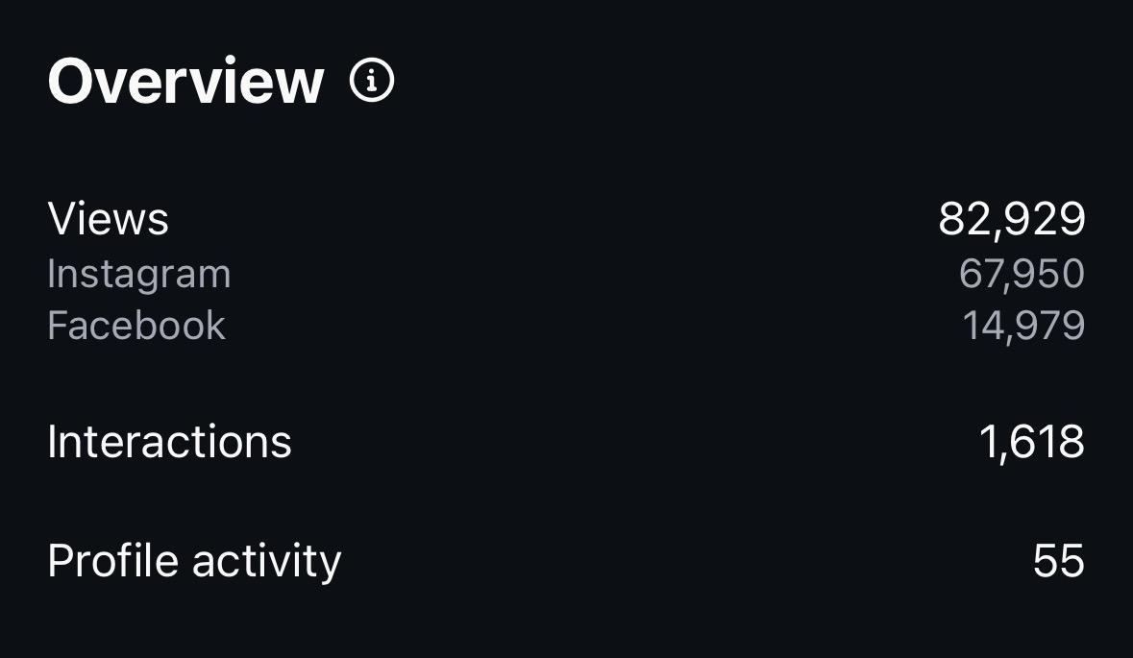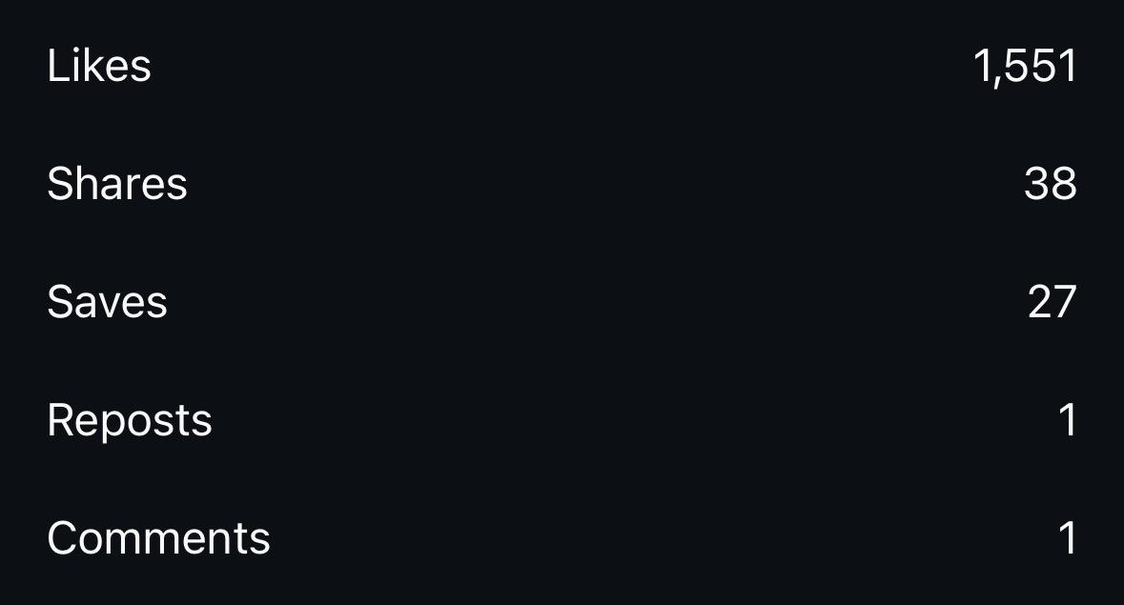

7. Varshangalkku Shehsam Reel (Jan 7)

https://www.instagram.com/reel/DTNquvVgRLn/?igsh=NnB1a21kdW1uZXc5

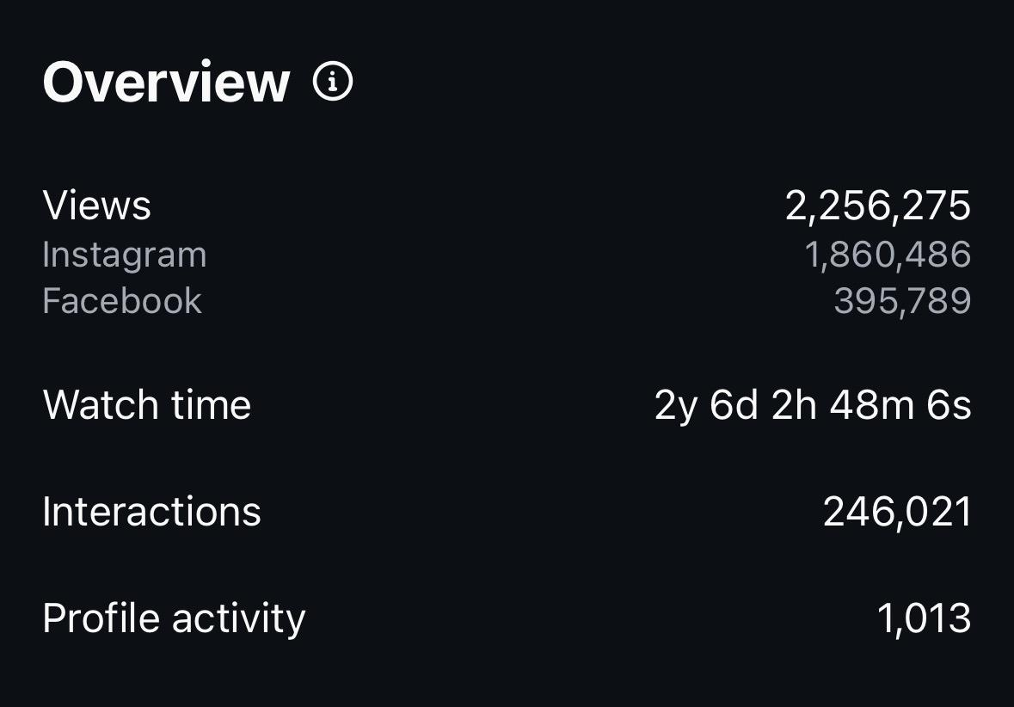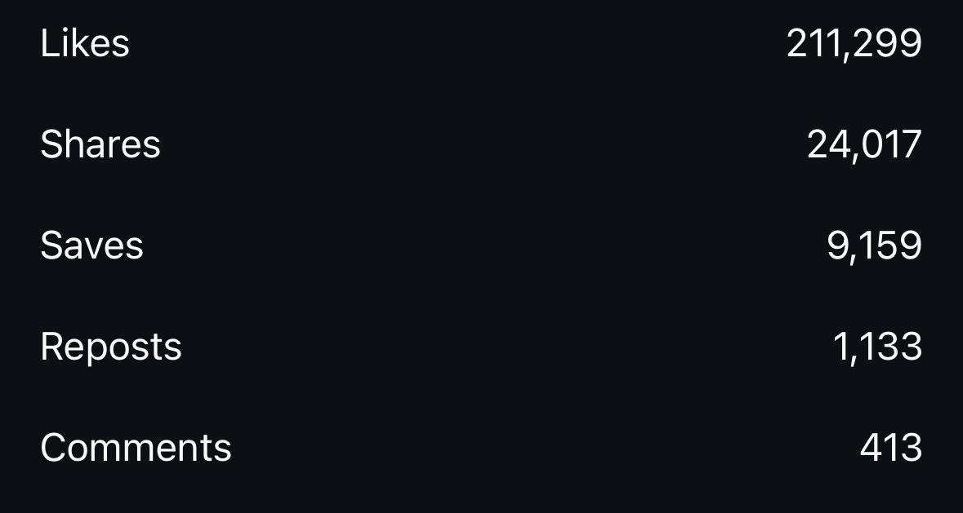

8. Nivin - Panorama Studios :Quick Bites Post (Jan 7):

https://www.instagram.com/p/DTNKkqVgbwq/?igsh=NHp5YmlubGVtNzNx

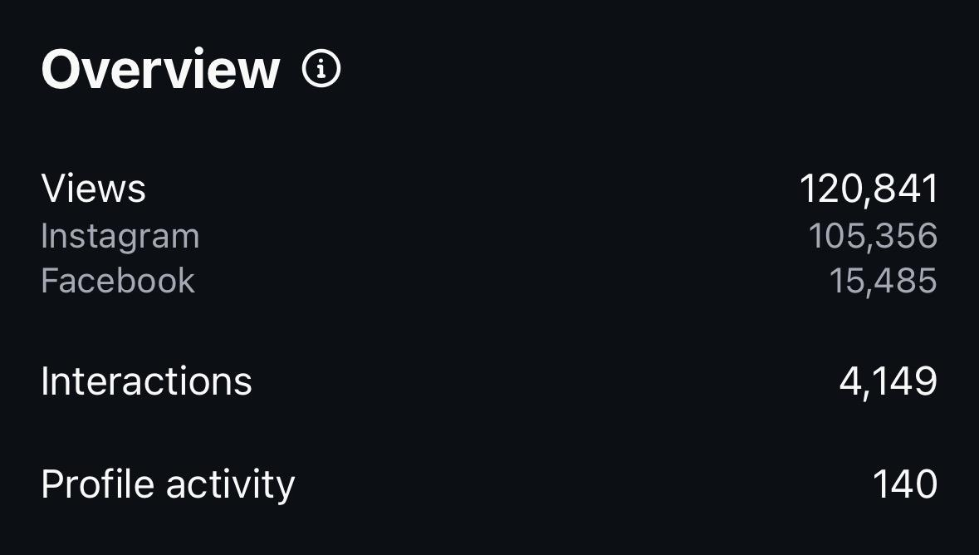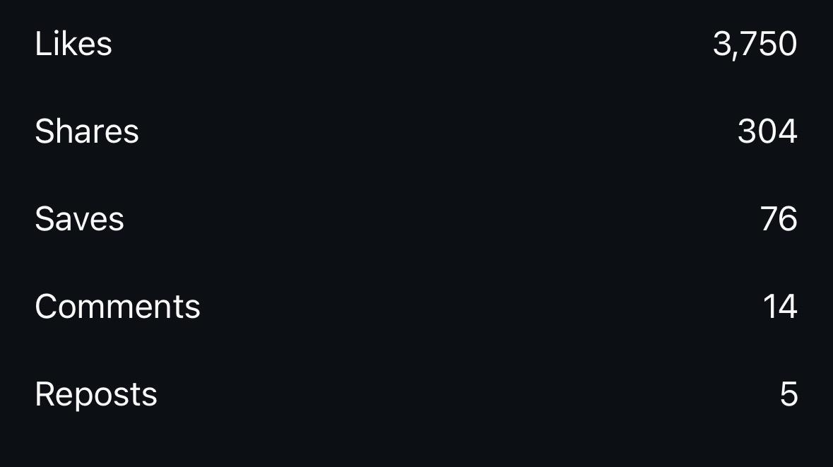

9.Sarvam Maya 100cr : Quick Bites Post (Jan 4):

https://www.instagram.com/p/DTFNtcFgbSk/?igsh=YXk3ZGUydm4xZHdp

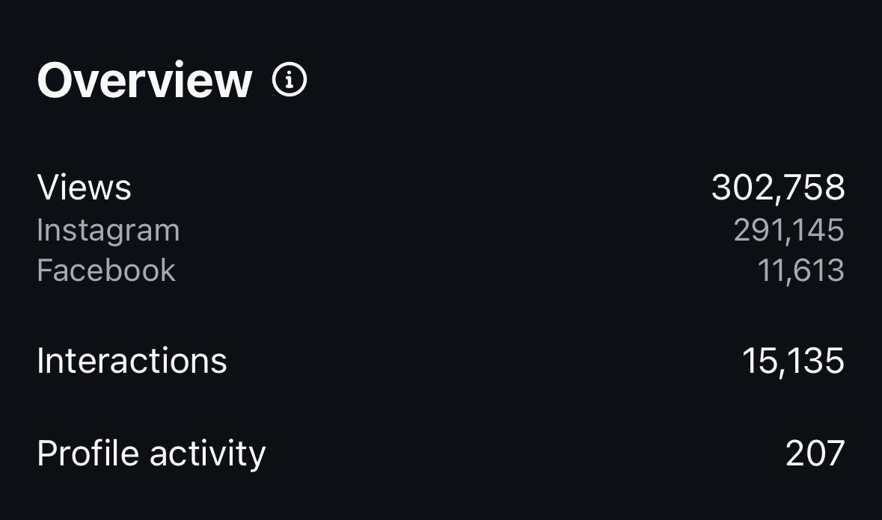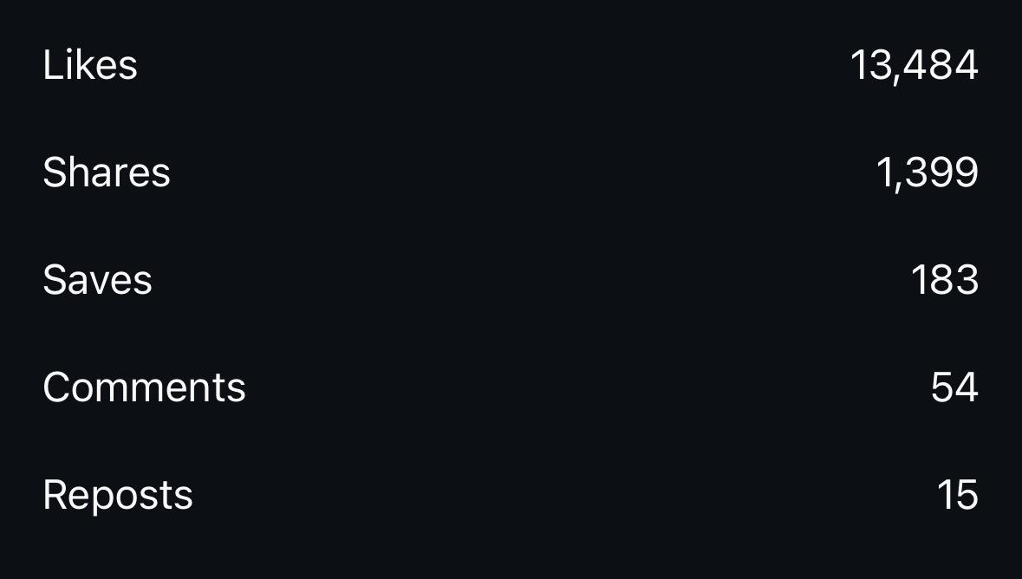

10. Bethlehem Kudumba Unit : Quick Bites Post (Jan 2):

https://www.instagram.com/p/DTAL1PUAdkG/?igsh=MWI0dm9yMG8yMTZ3cg==

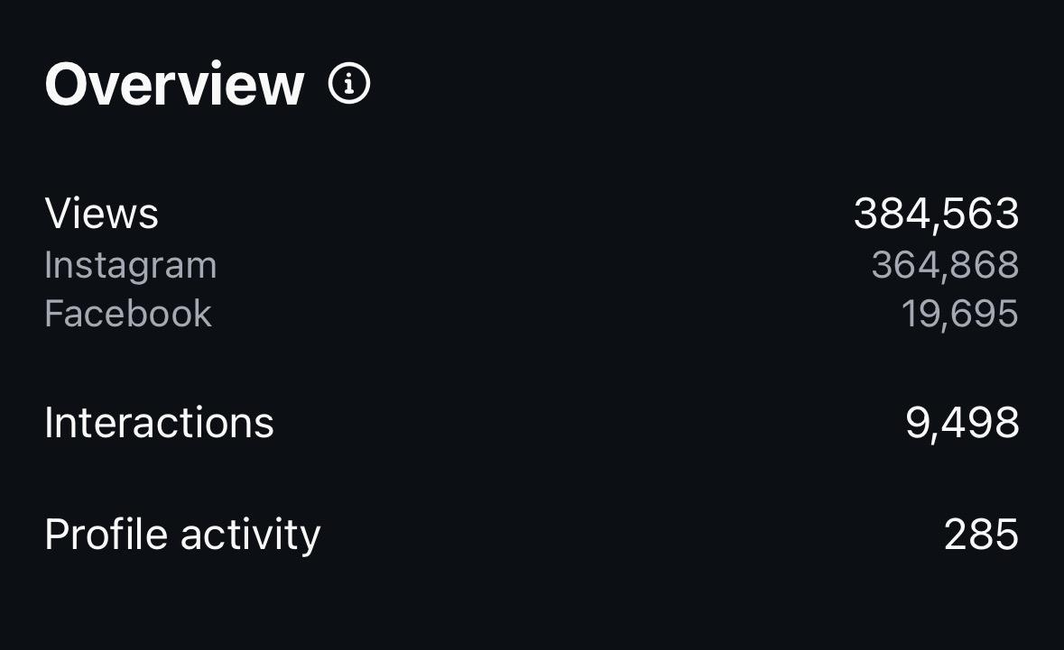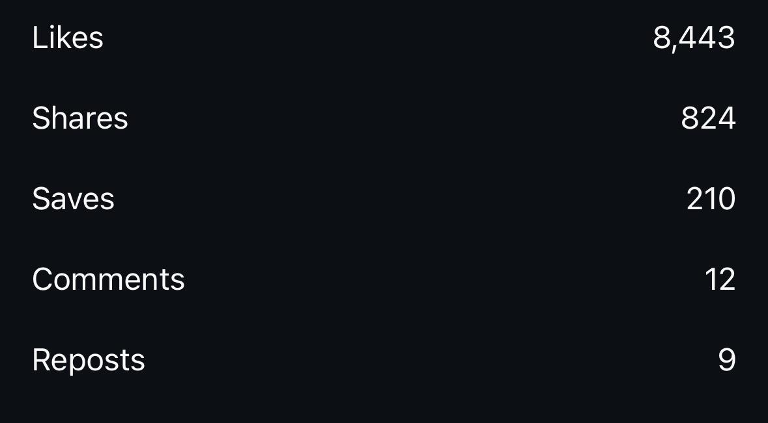

11.Sarvam Maya : Greatest Secrets Post(Jan 1):

https://www.instagram.com/p/DS9w29-AQRt/?igsh=MTdsd3NxMWQ4NHMzbQ==

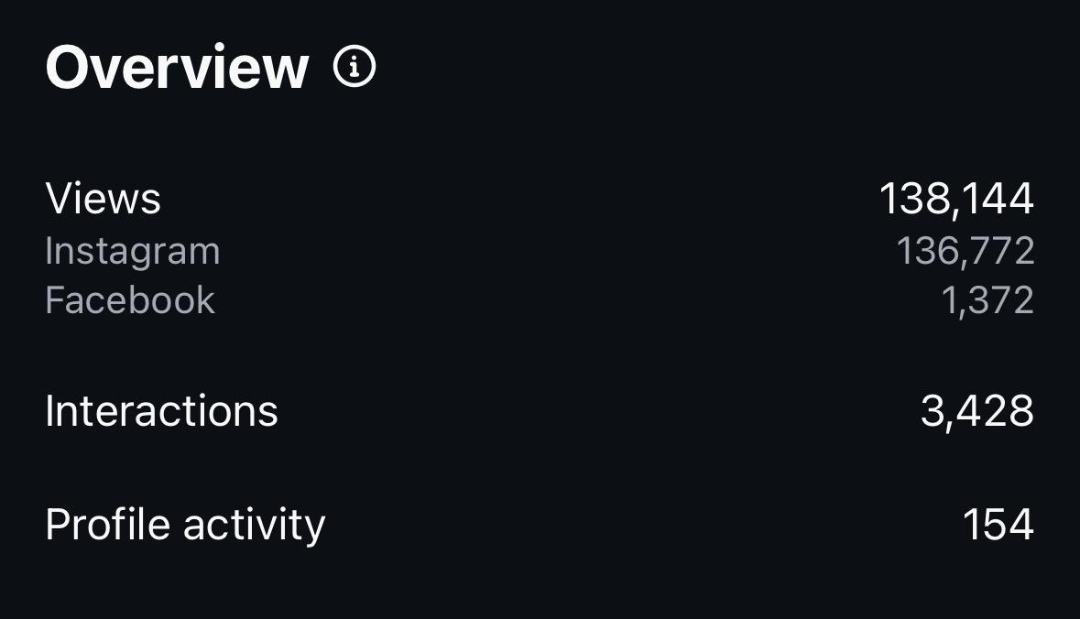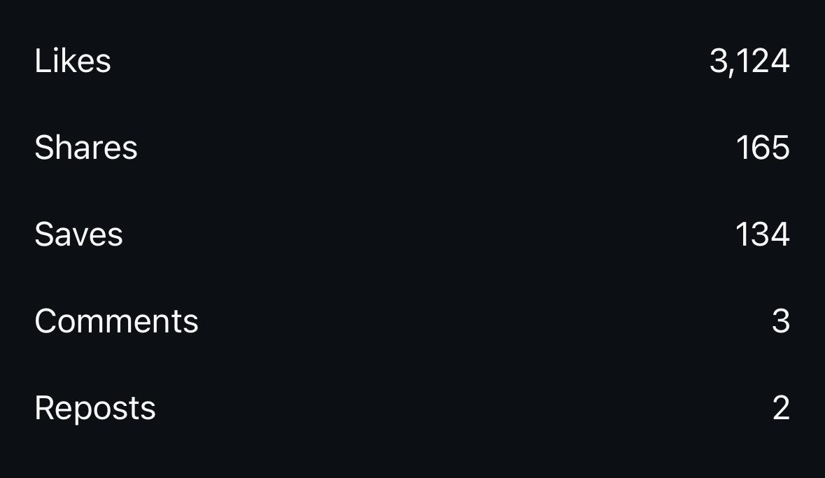

12. Aanandam Reel (Dec 27)

https://www.instagram.com/reel/DSxboTHgevD/?igsh=aTJtM2x0ZGNmMXNl

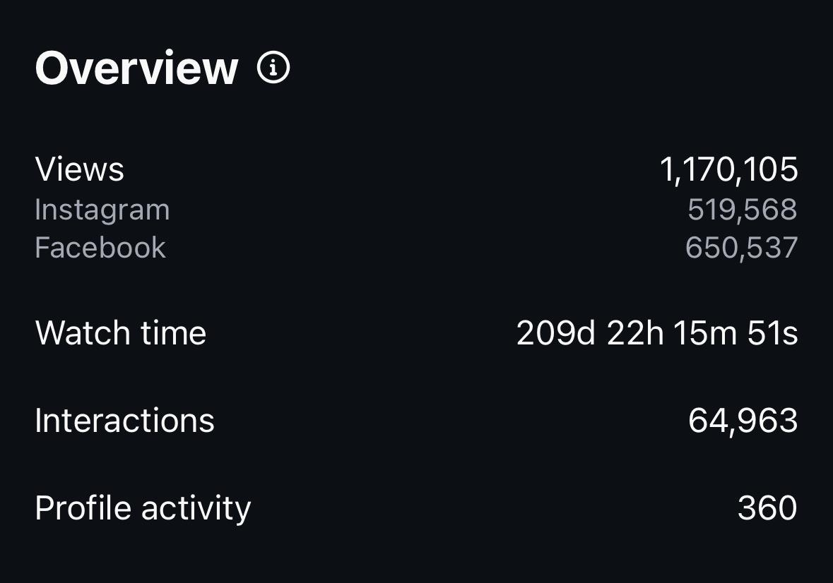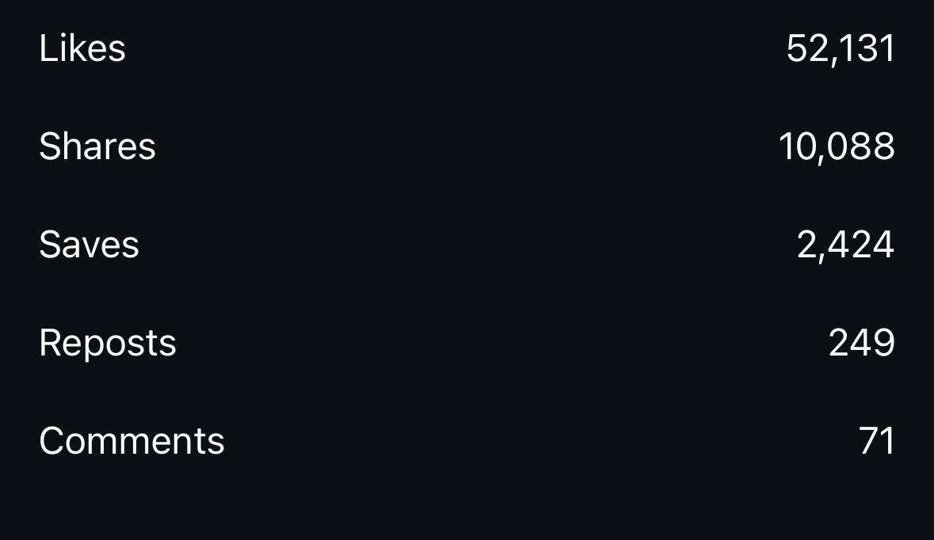

13.Sarvam Maya Release Day: Quick bitez Post (Dec 25):

https://www.instagram.com/p/DSrp-_1AbEb/?igsh=cm5tMWIycG1ocnlu

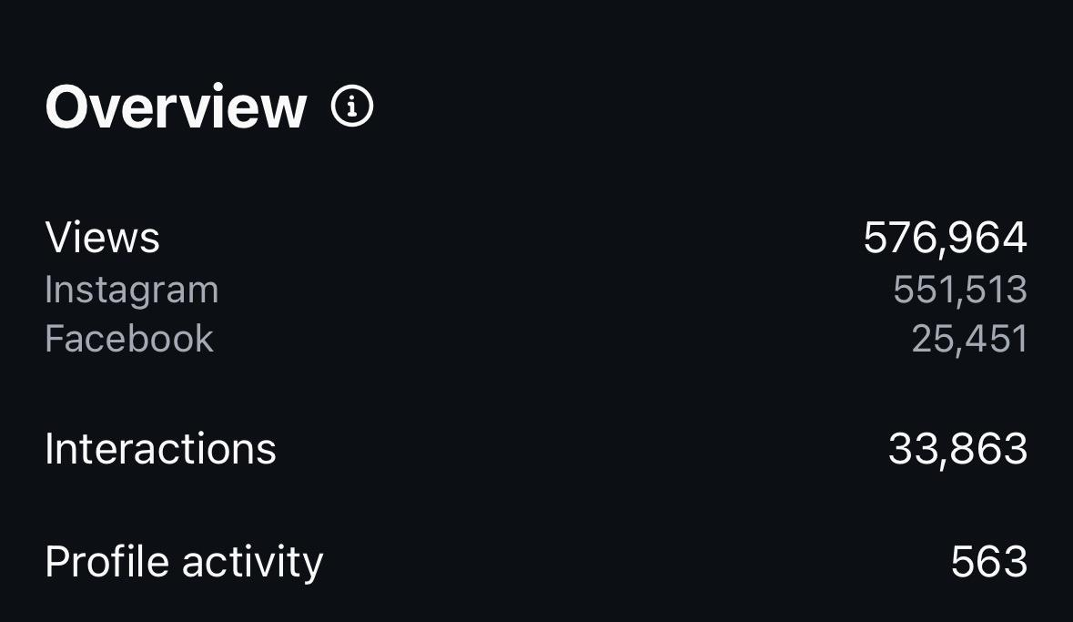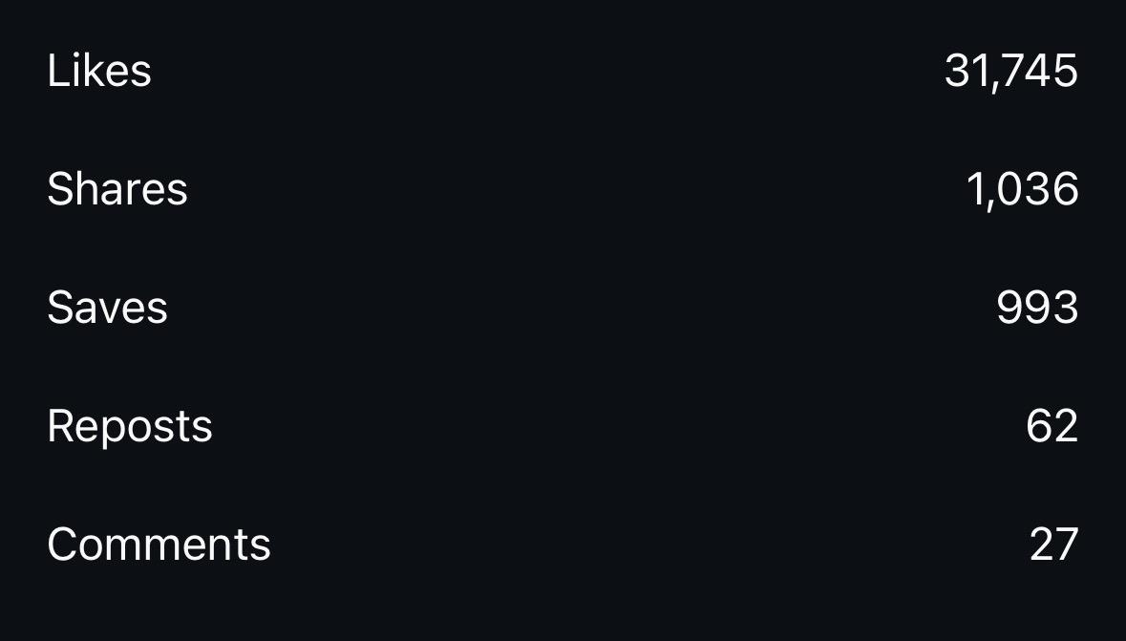

14. Action Hero Biju 2 : Quick Bites Post(Dec 22):
https://www.instagram.com/p/DSk2Tu9k8-4/?igsh=eWhoN2RrNHE5M3Br

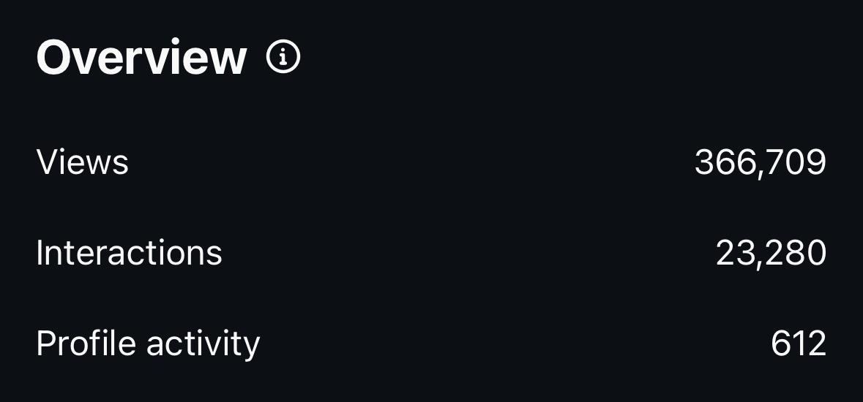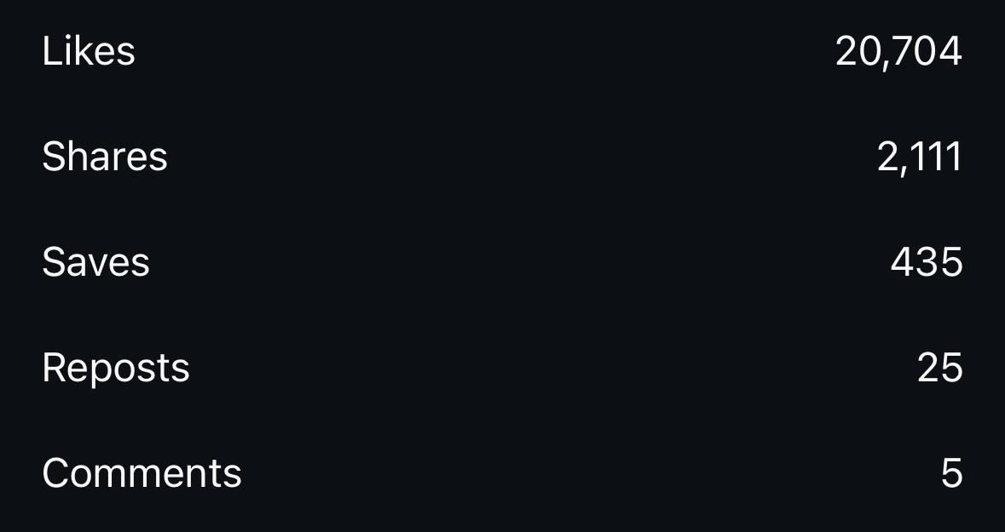

15. Sarvam Maya ; Quick bites post( Dec 19):

https://www.instagram.com/p/DScgwW9E_kp/?igsh=MXBqd2hqamsxb2ZmMg==

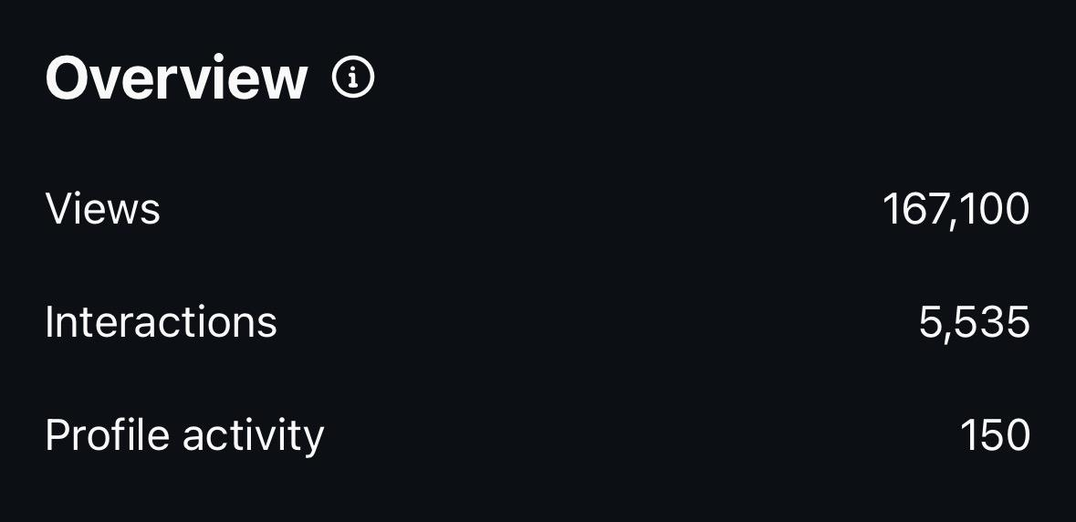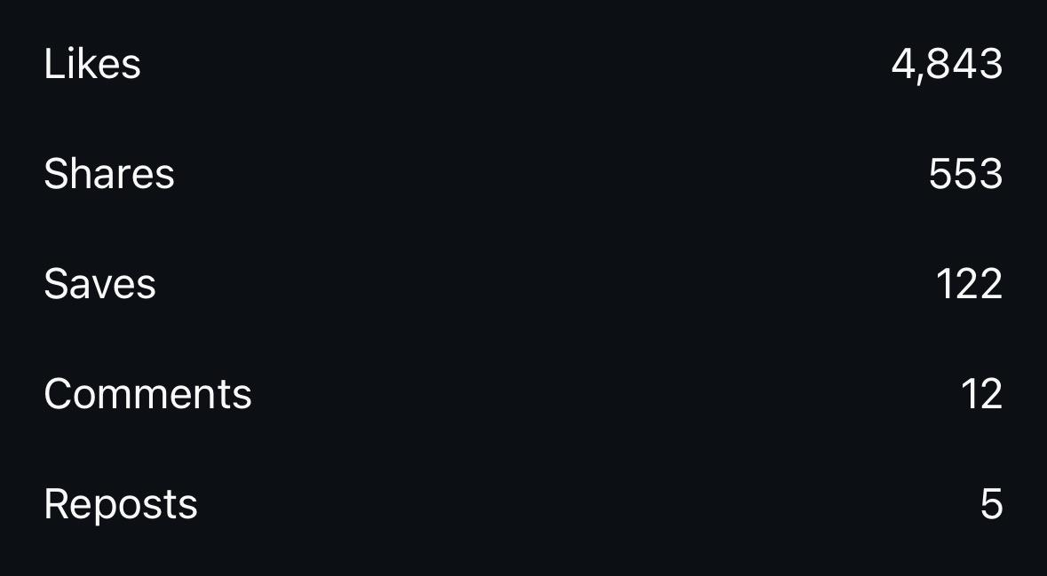

16. Compilation Post - Sarvam Maya Related(Dec 26):
https://www.instagram.com/p/DSu5_d1AUtj/?igsh=MWNkY3B4cTRhb2FxdA==

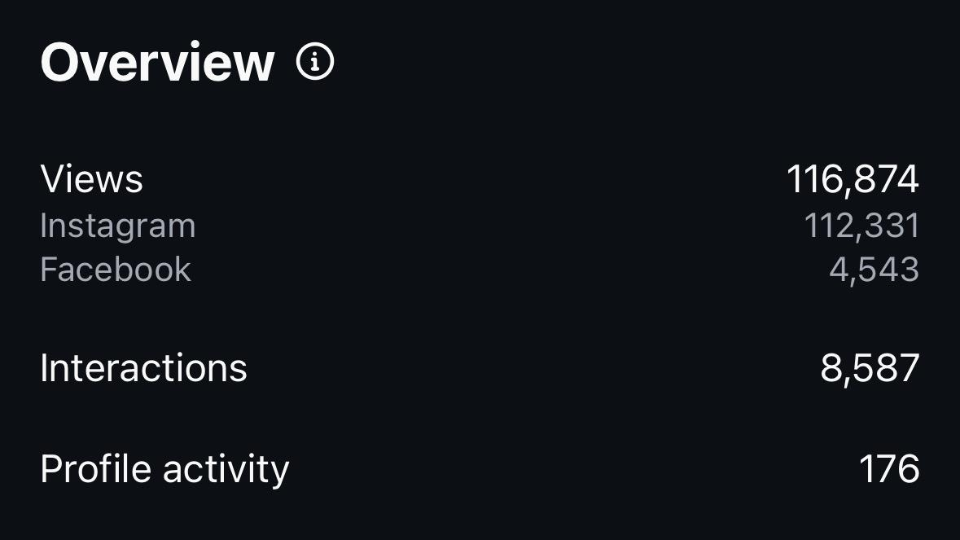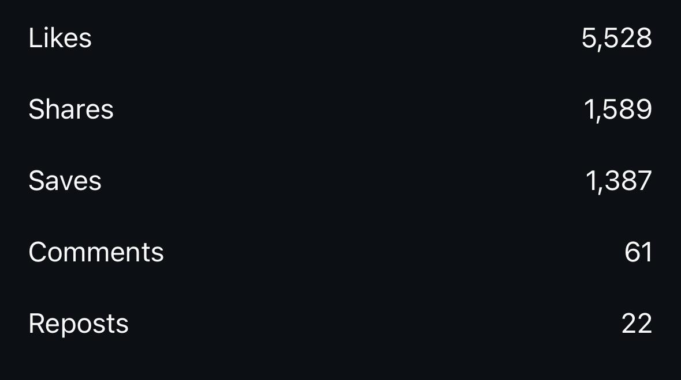

17. December Release post - Sarvam Maya in Cover Slide (Nov 30):
https://www.instagram.com/p/DRr2RQ6AZ-H/?igsh=MWw4ZGMwMDhsZnI0ZQ==

