✦ CHILD ARTIST CASTING PROFILE ✦
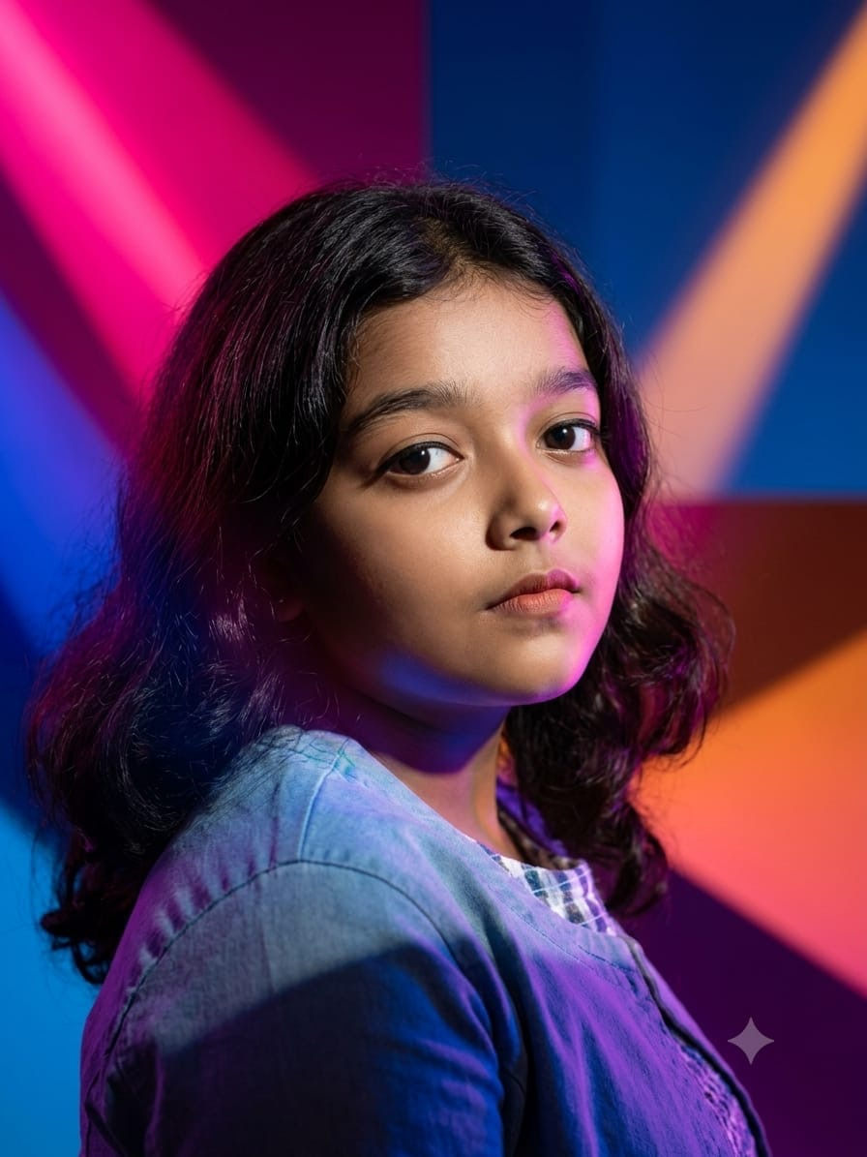
━━━━━━━━━━━━━━━━━━━━
ADWIKA R
ASPIRING ACTRESS • DANCER
Passionate about acting, dancing and creative performance.
✦ PERSONAL DETAILS
NAME | Adwika R
AGE | 12 years
DATE OF BIRTH | 18 December 2014
HEIGHT | 155 cm
LANGUAGES | Hindi • English • Malayalam
LOCATION | Palakkad, Kerala
SCHOOL | BSS Gurukulam, Alathur
SKILLS | Acting • Dancing

PARENT / GUARDIAN CONTACT
8330091698
Available for suitable child-artist auditions, acting opportunities and dance performances.

